**Cell Culture**

1. **Goal of vitro cell lines**
2. **Cell growth and division**
3. **Cell differentiation**
4. **Genetic manipulations for gene structure / function studies**
5. **Biotechnology**
6. **Isolation of the cells**
7. **proteases and collagenases**: Cells can be released from soft tissues by enzymatic digestion with proteases and collagenases
8. **Explant Culture:** Pieces of tissue can be placed in growth media, and the cells that grow out are available for culture

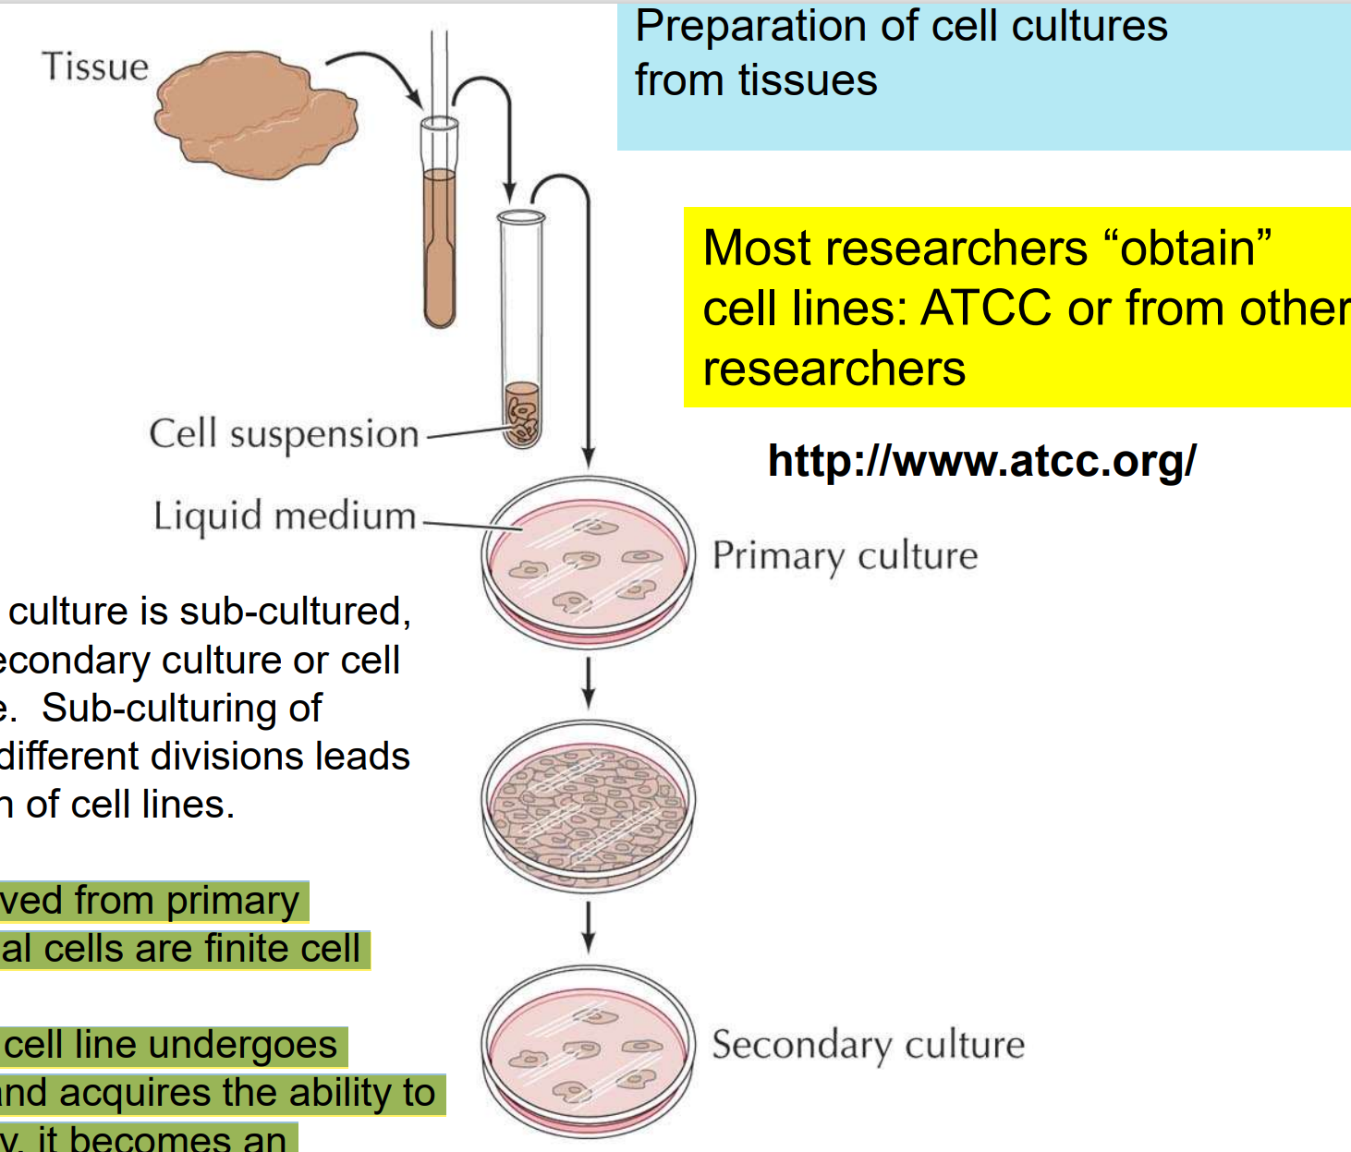

1. **Cell Types**

**Primary -> Immortalized**

1. Cell lines derived from **primary cultures** of **normal cells are finite cell lines.**
2. When a finite cell line undergoes **transformation** and acquires the ability to divide indefinitely, it becomes an established or immortalized cell line

**Ps: about the transformation:**

the deletion or mutation of the **p53 gene,** which would normally **arrest cell cycle** progression and **overexpression of the telomerase gene.**

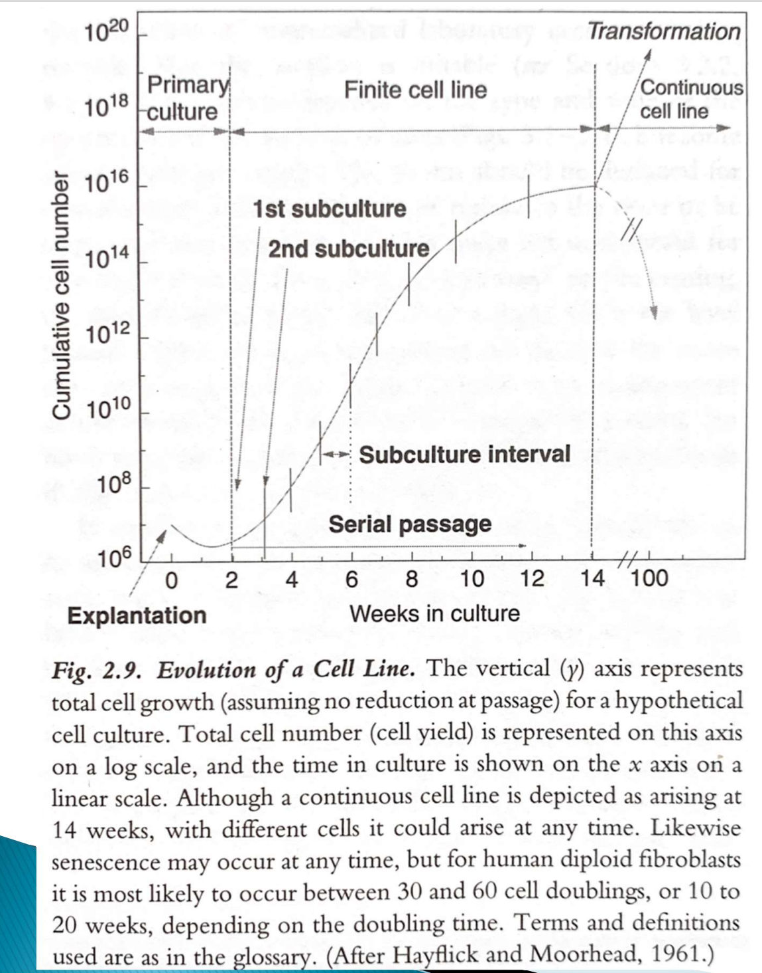

1. **Primary cultures:** cells cultured directly from a subject
2. **Immortalized(established) cell lines:** cell line has acquired the ability to proliferate indefinitely either through random mutation or deliberate modification.
3. **Cell Lines**
4. **HL-60 (Human leukemia cells)**
5. NG108-15 (Mouse neuronal cells)
6. SWSIS 3T3 (Mouse embryonic fibroblast)
7. HEK293T (Human embryonic kidney fibroblast)
8. MG63 (Human bone fibroblast)

Ps: Fibroblasts are the most common cells of connective tissue in animals. It synthesizes the extracellular matrix and collagen, the structural framework (stroma) for animal tissues.

1. **General Requirement**
2. Appropriate **temperature** and **gas** mixture (typically, 37C, 5% CO2 ) in a cell incubator
3. **pH**: 7.2-7.5 (buffering by sodium bicarbonate)
4. **Humidity** is required
5. **Glucose, growth factors**, and the presence of other **nutrient components**

Ps: Culture conditions vary widely for each cell type, and variation of conditions for a particular cell type can result in different phenotypes being expressed. }

1. Manipulate in a **biological safety cabinet** (“Tissue culture hoods”): prevent contamination

**Tips:** **Tissue culture hoods :** Tissue culture experiments are typically carried out in special work stations. Reduce the risk of microbial contamination by

* provide personal protection from harmful agents within the cabinet
* Environmental Protection from contaminants contained within the cabinet.

1. **Cell Media**
2. **Inorganic salts** (e.g. calcium chloride and sodium chloride) （retain the osmotic balance and help in regulating membrane potential by providing sodium, potassium, and calcium ions)
3. **Glucose** (carbon source)
4. **Amino acids** (protein synthesis) (L-glutamine, an essential amino acid, is particularly important. L-glutamine provides nitrogen for NAD, NADPH and nucleotides and serves as a secondary energy source for metabolism.) •Vitamins (biotin, B12, folic acids etc. - enzyme co-factors)
5. **Growth factors**: stimulate cell division, in general these are found in the serum (fetal bovine serum, FBS) which is added to the media
6. **Antibiotics** (penicillin or streptomycin ) to prevent the growth of unwanted organisms (e.g. Bacteria)
7. **Buffered by bicarbonate** (HCO3 - ) to ensure pH stability. Bicarbonate exists in equilibrium with carbonic acid (H2CO3 ) which in turn can be converted to carbon dioxide and water.

**Tips:**

1. High temperature, chemical corruption, medium protein degradation makes the color purple.
2. As cell number and metabolic by-products increase, the media becomes more acidic and turns yellow. The media needs to be changed and the cells split
3. **Biological Safety Cabinet**
4. Work at the proper sash level
5. Never cover the air grill
6. **Sterile handling & Aseptic Technique**

**Aseptic Technique**

**Goal**：**prevents contamination** of cell cultures and reagents by **microorganisms.**

1. **Cell Culture Room& Laminar Flow Safety Cabinet:** Cell culture should be carried out in a **laminar flow safety cabinet** located in a **room that is specific to cell culture.**
2. **70% ethanol** :The interior of safety cabinets should be **wiped with 70% ethanol** before and after use.
3. **UV: Ultraviolet (UV) light** can also be used to sterilize safety cabinets between uses.
4. **Uncluttered and only contain**: Areas of work should be **uncluttered** and contain **only the items** required for the current procedure

**Sterile handling**

1. **70% ethanol**
2. Spray gloved hands with 70% ethanol before commencing work in the safety cabinet.
3. When bringing equipment or reagents into safety cabinets, spray them beforehand with 70% ethanol.
4. **Aseptic Technique:**
5. Sterilize everything likely to come into contact with the culture.
6. Media and glassware may be autoclaved
7. disposable plastic ware has been sterilized by radiation or treatment with gas, and should remain wrapped before use
8. tools and implements can be dipped in alcohol and flamed.
9. use a laminar flow hood, whose air environment is filtered to remove particles.
10. Avoid opening sterile containers for longer than necessary to sample or inoculate.
11. add antibiotics such as penicillin or streptomycin in the culture medium
12. **Open single item one time**

Never open multiple flasks, dishes or bottles at the same time, this may result in cross contamination

1. **Protein Assay**
2. **PBS**
3. **Goal:** washing and dilution of cell culture
4. **Composition**:
5. sodium chloride
6. sodium phosphate
7. potassium phosphate
8. **pH** = 7.4
9. **Osmotic pressure:** isotonic
10. **Bradford reagent**

Bradford reagent contains a dye, Coomassie blue, which binds to protein.

The dye/protein complex produces a blue color whose absorbance is directly proportional to the protein concentration.

1. **BSA (bovine serum albumin)**

BSA has been prepared in PBS at a concentration of 0.6 mg/mL. 2. Using an aliquot of the 0.6 mg/mL

1. **Cell growth curve**
2. **Exponential phase**

* dN/ dt = kN -> dN/N = kdt
* In (N/No) = kt(The population doubling time is the value of t for which N/No = 2)
* limited by the availability of nutrients or the environment's carrying capacity for waste.

1. **Stationary Phase**

* cell death balances cell division and even cell division may be slowed.
* Cells in adult organs of most higher animals are in stationary phase.

1. **Death phase**

* conditions become sufficiently adverse, a death phase may ensue.

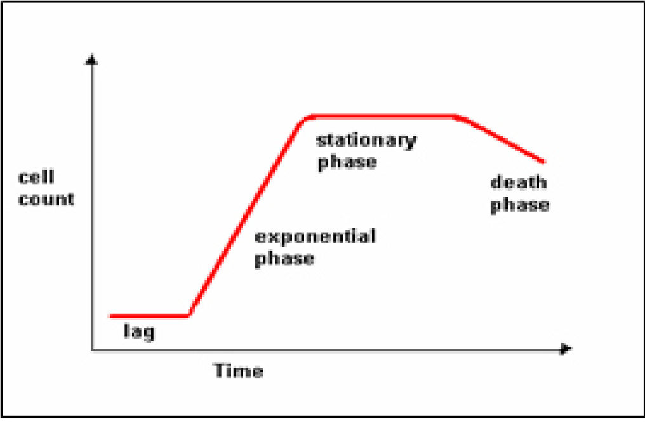

1. **Cell Number Measurement**

**• Hemocytometer**

**• Electronic cell counting(large number)**

In which a particle passing over a charged orifice interrupts the charge and is

recorded as a pulse. The number of pulses is a measure of the number of particles in the

volume that flowed past the orifice.

• **Using protein assay to monitor cell growth**

**(characteristics of the cell or to compare one cell type to another)**

how much protein a cell contains

Once that value is obtained, one can use the amount of protein in a cell lysate

as a measure of the number of cells lysed.

1. **Procedure**

**A. Construction of Growth Curve of HL-60 cell culture**

* A stock culture of HL-60 cells in log phase will be provided in a 37C incubator containing 5% CO2
* **condition**
* one under **optimum conditions** **(RPMI 1640 medium containing 20% fetal bovine serum (FBS)** )
* one under **sub-optimum conditions (RPMI 1640 medium containing 4% FBS).**

1. **Transfer 16 mL of 1640 with 20% FBS to a T75 sterile flask, labeled 20%; and 16 mL of 1640 with 4% FBS to another T75 flask, labeled 4%.**

2. T**ransfer 4 mL of the stock cell culture t**o both flasks from Step 1.

3. Gently **shake** the flasks several times. Label the flasks

4. Take 0.2 mL of “20%” and 4% to t**wo microfuge tubes.**

5. Use the **hemocytometer** to determine the concentration of cells

6. **Calculate the mean (the average number of cells/square) and standard deviation** of readings from the eight “A” squares on the hemocytometer.

The concentration of cells in the sample is given by the mean count x 10^4 cells/mL. Remember to correct this concentration by the dilution factor if required, and to convert the unit to x 10^6 cells/ml. Record all data on the Experimental Datasheet accordingly.

7. **On day 1, 3, 5 and 6,** repeat Step 4 for sampling of your two cultures.

**B. Preparation of Cell Pellet for Protein Assay**

1. **Transfer 1 mL of cell suspension from “20%” and “4%”** culture flasks Label the test tubes

2. Using a **swing out rotor and centrifuge,** spin down the cells at 3,000 revolutions per

minute (rpm) for 5-minutes.

3. When the rotor comes to rest, **remove tubes and carefully discard the supernatant**

4. **Resuspend the cell pellets with 0.5 mL phosphate buffered saline (PBS).**

5**. Repeat the centrifugation step as in Step 2** to obtain the cell pellets again.

Discard the supernatant and save the pellet.

6. **Store the samples (cell pellet) at -20C.**

6. **Repeat Step 1 to 4** on each sampling day of Part B and save the corresponding

cell pellets for lab session of next week.

**C. Construction of Protein Standard Plot (Bradford Assay: 96-well plate)**

* use **Bradford reagent** to determine the protein content of **bovine serum albumin (BSA)**

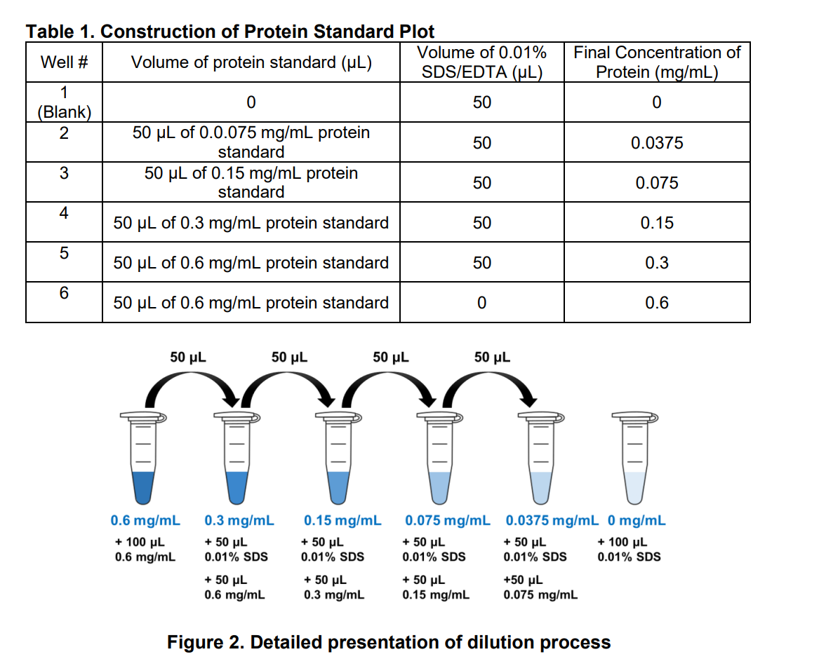**D. Cell Lysis and Protein Assay**

1. To lyse the cells, **suspend each cell pellet in 0.5 mL 0.1% SDS/EDTA.**

2**.** Break up the clumps of cells by **vortex.**

3. **Immerse the tube in 95C test tube** heat blocks for a minute or two, to help the

proteins go into solution.

4. Once the pellet is solubilized, **dilute each sample 10 folds by adding 20 μL of each**

**cell sample into 180 μL of ddH2O.** Mix the content by vortex.

5. Add 10 μL of standard or cell lysate sample (3 repeat) to the appropriate **wells on 96-**

**well plate.**

6. **Add 200 μL of Bradford reagen**t to each well. Wait for 3-minutes. Full color

development should occur within 3-minutes.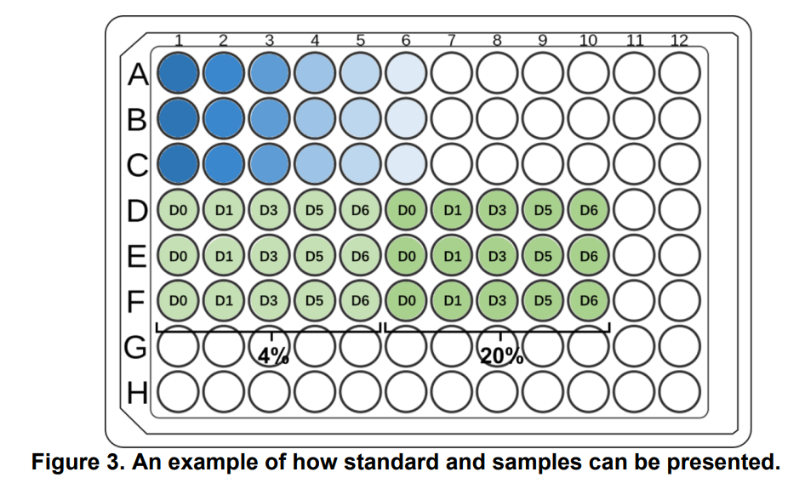

7. After 3-minutes, measure absorbance at 595 nm with microplate spectrophotometer

(BioTek Epoch plate reader). Record the absorbance value on the datasheet (P. 9).

8. Calculate the coefficient of determination and slope of the regression line. The coefficient should be > 0.9.

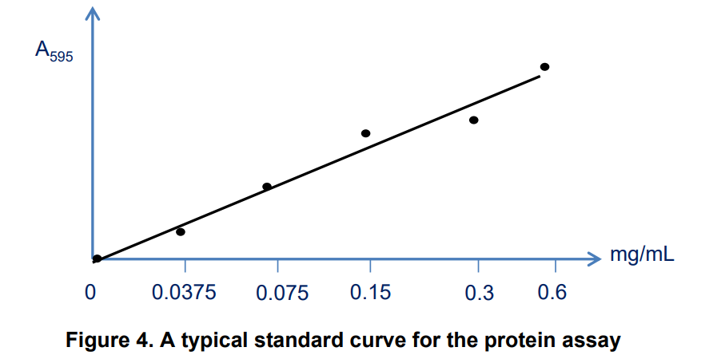

9. Calculate the amount of protein per well. Correcting for dilutions (if necessary), calculate the total amount of protein per ml in each lysate.

10. Calculate the amount of protein per cell in terms of nano grams (ng) of protein per cell.